Overview of the clang generated Abstract Syntax Tree (AST)
What is clang?
Clang is a compiler front end for C, C++, Objective-C, and Objective-C++ programming languages. It also supports the OpenMP, OpenCL, CUDA and Renderscript frameworks. It used the LLVM compiler infrastructure as its back end. It was created as Apple software makes heavy use of Objective-C’s front end which is a low priority for GCC, GCC didn’t integrate well into Apples IDE and because GCC is licenced under a licence that requires developers who distribute extensions for GCC to make their source code available. In compiler design, a front end takes care of the analysis part, which means breaking up the source code into pieces according to a grammatical structure. In concerte terms, the front end is responsible for parsing the source code, checking for errors and creating an Abstract Syntax Tree.
What is an Abstract Syntax Tree?
An Abstract Syntax Tree (or AST) is a structured tree representation of the abstract syntax of source code. It is used for purposes such as creating a symbol table, performing type checking, and finally, generating code. The difference between Clang’s AST and ASTs produced by some other compilers is that Clang’s AST closely resembles both the written C++ code and the C++ standard.
Now we will take a look at the Abstract Syntax Tree lines 25 – 53 for the attached t2.ast and how it corresponds with the while loop of the t2.c file also attached.
AST
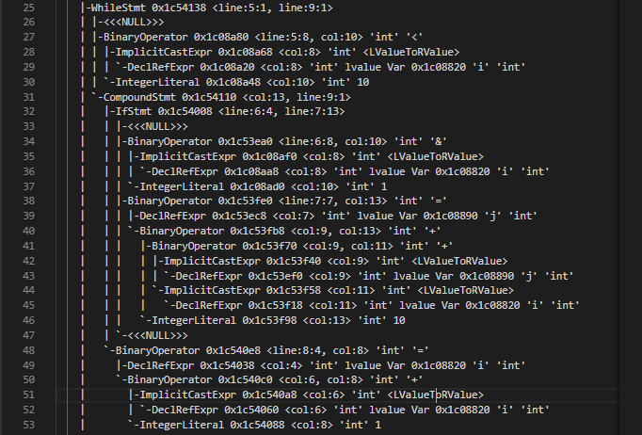
C
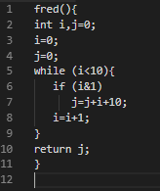

The following lines are related to: while (i<10){
|-WhileStmt 0x1c54138 <line:5:1, line:9:1> //This represents the while statement. The hexadecimal represents it’s address on the stack. The <line5:1, line9:1> shows that the code begins at line 5 column 1 which is the “w” and ends at the first column of line 9 with the closing brace.
| |-<<<NULL>>> The while statement can optionally have conditional variables, however in this case there is no conditional variable, so <<<NULL>>> is printed instead. Since it is a part of the While Statement it is indented in it.
| |-BinaryOperator 0x1c08a80 <line:5:8, col:10> 'int' '<' This expression describes a binary operation in this case “i <”. The hexadecimal represents its address on the stack. The ‘int’ is the integer i that was created in line 2 of the c code. The ‘<’ is a greater than operator.
| | |-ImplicitCastExpr 0x1c08a68 <col:8> 'int' <LValueToRValue> ImplicitCastExpr allows us to explicitly represent implicit type conversions that have no direct representation in the original source code. This line checks the value of the right hand side (which is an int) and converts the value on the left to the same value. It is a child of the Binary Operator.
| | | `-DeclRefExpr 0x1c08a20 <col:8> 'int' lvalue Var 0x1c08820 'i' 'int' shows a reference to the declared variable “i” created in line 2 of t2.c. It is of type int.
| | `-IntegerLiteral 0x1c08a48 <col:10> 'int' 10 this turns the string 10 into the int 10.
The purpose of the lines Binary Operator as far as IntergerLiteral is to compare int i to the number 10.
| `-CompoundStmt 0x1c54110 <col:13, line:9:1> This is a group of statements, in this case it is the scope of the while loop. The columns mentioned are both curly braces, between them is everything is in the scope.

The following lines are related to: if (i&1)
| |-IfStmt 0x1c54008 <line:6:4, line:7:13> This represents an if/then/else statement. In this case it represents a simple if statement.
| | |-<<<NULL>>> The while statement can optionally have conditional variables, however in this case there is no conditional variable, so <<<NULL>>> is printed instead. Since it is a part of the While Statement it is indented in it.
| | |-BinaryOperator 0x1c53ea0 <line:6:8, col:10> 'int' '&' This expression describes a binary operation in this case “i &”. The hexadecimal represents its address on the stack. The ‘int’ is the integer i that was created in line 2 of the c code. The ‘&’ is the and operator.
| | | |-ImplicitCastExpr 0x1c08af0 <col:8> 'int' <LValueToRValue> ImplicitCastExpr allows us to explicitly represent implicit type conversions that have no direct representation in the original source code. This line checks the value of the right hand side (which is an int) and converts the value on the left to the same value. It is a child of the Binary Operator.
| | | | `-DeclRefExpr 0x1c08aa8 <col:8> 'int' lvalue Var 0x1c08820 'i' 'int' shows a reference to the declared variable “i” created in line 2 of t2.c. It is of type int.
| | | `-IntegerLiteral 0x1c08ad0 <col:10> 'int' 1

The following lines are related to: j=j+i+10;
| | |-BinaryOperator 0x1c53fe0 <line:7:7, col:13> 'int' '=' This expression describes a binary operation in this case “j=j”. The hexadecimal represents its address on the stack. The ‘int’ is the integer i that was created in line 2 of the c code. The ‘=’ is the equals operator.
| | | |-DeclRefExpr 0x1c53ec8 <col:7> 'int' lvalue Var 0x1c08890 'j' 'int' shows a reference to the declared variable “j” created in line 2 of t2.c. It is of type int.
| | | `-BinaryOperator 0x1c53fb8 <col:9, col:13> 'int' '+' This expression describes a binary operation in this case “i+10”. The hexadecimal represents its address on the stack. The ‘int’ is the integer i that was created in line 2 of the c code. The ‘+’ is the equals operator.
| | | |-BinaryOperator 0x1c53f70 <col:9, col:11> 'int' '+' This expression describes a binary operation in this case “j+i”. The hexadecimal represents its address on the stack. The ‘int’ is the integer j that was created in line 2 of the c code and equals 0 by default. The ‘+’ is the equals operator.
| | | | |-ImplicitCastExpr 0x1c53f40 <col:9> 'int' <LValueToRValue> ImplicitCastExpr allows us to explicitly represent implicit type conversions that have no direct representation in the original source code. This line checks the value of the right hand side (which is an int) and converts the value on the left to the same value. It is a child of the Binary Operator.
| | | | | `-DeclRefExpr 0x1c53ef0 <col:9> 'int' lvalue Var 0x1c08890 'j' 'int' shows a reference to the declared variable “j” created in line 2 of t2.c. It is of type int.
| | | | `-ImplicitCastExpr 0x1c53f58 <col:11> 'int' <LValueToRValue> ImplicitCastExpr allows us to explicitly represent implicit type conversions that have no direct representation in the original source code. This line checks the value of the right hand side (which is an int) and converts the value on the left to the same value. It is a child of the Binary Operator.
| | | | `-DeclRefExpr 0x1c53f18 <col:11> 'int' lvalue Var 0x1c08820 'i' 'int' shows a reference to the declared variable “i” created in line 2 of t2.c. It is of type int.
| | | `-IntegerLiteral 0x1c53f98 <col:13> 'int' 10 this turns the string 10 into the int 10.
| | `-<<<NULL>>> The while statement can optionally have conditional variables, however in this case there is no conditional variable, so <<<NULL>>> is printed instead. Since it is a part of the While Statement it is indented in it.

The following lines are related to: i=i+1;
| `-BinaryOperator 0x1c540e8 <line:8:4, col:8> 'int' '=' This expression describes a binary operation in this case “i=1”. The hexadecimal represents its address on the stack. The ‘int’ is the integer i that was created in line 2 of the c code. The ‘=’ is the equals operator.
| |-DeclRefExpr 0x1c54038 <col:4> 'int' lvalue Var 0x1c08820 'i' 'int' shows a reference to the declared variable “i” created in line 2 of t2.c. It is of type int.
| `-BinaryOperator 0x1c540c0 <col:6, col:8> 'int' '+' This expression describes a binary operation in this case “i+1”. The hexadecimal represents its address on the stack. The ‘int’ is the integer j that was created in line 2 of the c code and equals 0 by default. The ‘+’ is the equals operator.
| |-ImplicitCastExpr 0x1c540a8 <col:6> 'int' <LValueToRValue> ImplicitCastExpr allows us to explicitly represent implicit type conversions that have no direct representation in the original source code. This line checks the value of the right hand side (which is an int) and converts the value on the left to the same value. It is a child of the Binary Operator.
| | `-DeclRefExpr 0x1c54060 <col:6> 'int' lvalue Var 0x1c08820 'i' 'int' shows a reference to the declared variable “i” created in line 2 of t2.c. It is of type int.
| `-IntegerLiteral 0x1c54088 <col:8> 'int' 1 this turns the string 1 into the int 1.

